(Approx. 352 words)

Security Tips - October
By David Shulman, WPCUG Weekly Update editor, intergroup liaison, and a co-organizer of WPCUG’s Meetup
October 2018 issue, WestchesterPCNews
www.wpcug.org
intergroupliaison (at) wpcug.org

This month and next, I will be catching up on the security news that has broken over the summer and in September. Rather than breaking news, I will try to concentrate on a bigger view, which is a continuation of last spring’s trend. UNFORTUNATELY, the bad security news has become a flood.

Remember the Equifax breach that affected 143+ millions of Americans’ data? HOLD ON TO YOUR HAT! Both Komando and “Wired” magazine detail a breach that affects 340-million U.S. adults and children. EXACTIS, a media and data aggregation firm, has leaked data for U.S. citizens. The data included phone numbers, home addresses, email addresses, interests, and even the number, age, and gender of their children. For more information, listen to this Komando podcast: www.komando.com/listen/episode/100000702/whatis-exactis-and-how-did-it-leak-the-data-of-nearlyevery-american

Here is some GOOD NEWS! The U.S. is issuing new Medicare cards, which will have a completely different number.

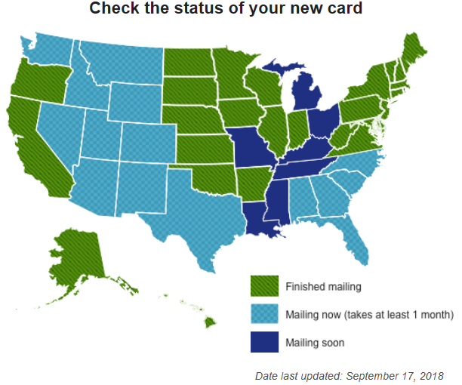

https://www.medicare.gov/newcard

Malwarebytes is the new short name for what used to be called “Malwarebytes Antimalware.” They have a good blog I want to point you to this month. Their software is generally considered very good, have both Mac and PC versions, and their product uses minimal computer resources. This URL is a good read and worth your time. https://blog.malwarebytes.com/cybercrime/2018/07/trojans-whats-the-real-deal

I’m ending this column with a personal story. A friend has an iMac. He is a retired person from law enforcement and thoroughly convinced that: 1) Macs are invulnerable to malware, and 2) passwords are really useless because if someone wants to get you they will. This attitude has recently led him, despite a thoroughly benign online behavior, to have an almost completely unworkable machine. Without discussing it with me, he contracted with a firm to clean up his computer remotely and maintain it at a cost of several hundred dollars PER YEAR. I know this because his computer recently sent me a virus containing email. A text to him and his call to me revealed the story. WORD TO THE WISE?

